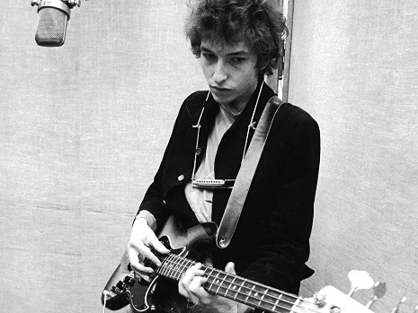
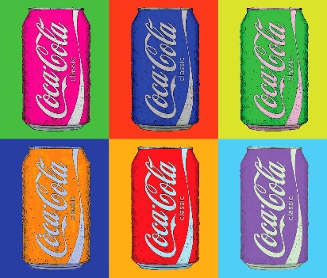
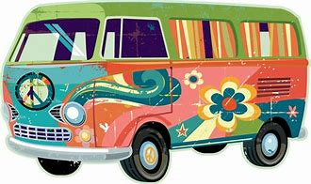

The Sixties A Decade of Rebellion, Music and Art
Hello students, this is a fun assignment where you can research what music and art was popular in the sixties.
The 60’s was a time of student rebellion to war and the government. Many great artists emerged at that time like Andy Warhol and Jackson Pollock. Music really took off with the Beatles, Rolling Stones, Bob Dylan, etc.
If you are able, you can research an artist from the 60’s and listen to their music or look up their artwork. As you are listening to their music, look at album cover designs that represent the time and fashion.
Possible optional assignments:
- Sketch your own album design that reflects the era. Try this with either pencil, crayon, pastel, watercolor, acrylic, etc. if you have the supplies. If you do not just sketch with a pencil for fun and relaxation.
- In Office 365 produce a Power point or Microsoft Word presentation on the musician of your choice from the 60’s. Research where they grew up, their education, most popular songs, hobbies, where they are now, etc. Talk to your parents, grandparents, guardians, etc. about your findings…use the phone and call them (social distancing)
- In Office 365 produce a Power point or Microsoft Word presentation on artist of your choice from the 60’s(Jackson Pollock, Andy Warhol, etc.). Research where they grew up, their education, most popular works, hobbies, where they are now, etc. Talk to your parents, grandparents, guardians, etc. about your findings…use the phone and call them (social distancing)
Note: If you are doing a Power Point or Word Presentation play around with the animations and transitions to keep yourself sharp. Try inserting a video or music. Use YouTube for help with any of these options or email me. LeRoy.Vincent@nbed.nb.ca
Try this site to enrich your knowledge on Jackson Pollock:
http://www.jacksonpollock.org/

